**Software Engineering Tools Lab**

**Assignment No-3**

(Module 3- GitHub) **Due date-23/02/2022**

Q 1. Create a repository on GitHub named SET Lab and add files into it (you can add implementation files of previous assignment) perform below operations on it. (Add screenshot as an answer to every question)

1. Perform commit on added files
2. Perform update to the existing files (show history)
3. Create another branch
4. Create pull request
5. Perform merging of both branches
6. Perform Fork operation

Q 2. For the diagram given below create a GitHub repository and perform operations given in the diagram. (Perform commit operations as given)(Add screenshots as an answer to this question)

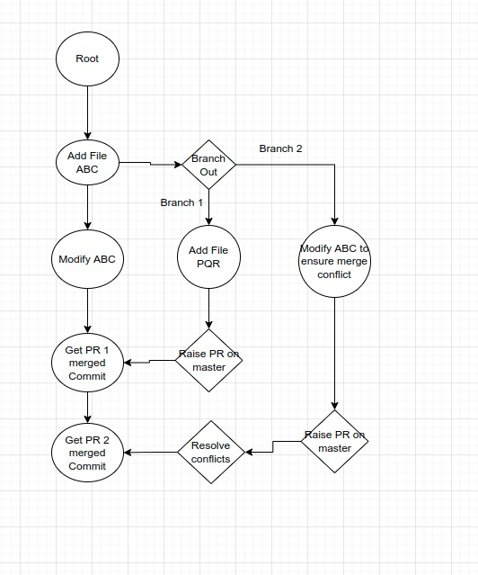

Q 3. What is GitHub desktop? How to install GitHub on local machine? Install GitHub on your local machine and access repository created in question no 1 (add screenshots).

Q 4. Differentiate in between GitHub, Git and GitLab.

Q 5. Go to this <https://github.com/sidp1991/SETAssignment>

GitHub repository add your code file (question no 2 solved in assignment no 2) in this repository, then open file [Student assignment updates.txt](https://github.com/sidp1991/SETAssignment/blob/main/Student%20assignment%20updates.txt) present in above repository and update your details such as Name and PRN and then perform commit( need to create pull request with appropriate comments). (Attach screenshots of this activity)